Allocate Plus
First-in First-serve mode

Welcome to the Allocate Plus video for students.
The focus of this video is how students can allocate themselves to activities in First-in First-serve mode.
Click on a group that is marked Allocated. The activity options for this group are displayed on the right, and each activity relates to a specific class venue and time. Only one activity option needs to be selected in each group.
The activity option is set to Allocated, which means you have already been allocated to an activity in this group.
Click on a group that is marked Pending or Unconfirmed. Again the activity options for this group are displayed on the right. Full means that currently no space is available in this activity. However, as students make changes to their enrolments and allocations, class times may become available. An activity displayed as Full, will convert to Select, if a place becomes available. You can keep checking regularly to see if times more suitable to your schedule become available. Clash means that this option clashes with another option that has previously been allocated and Select means that this option is available for you to allocate to your timetable.
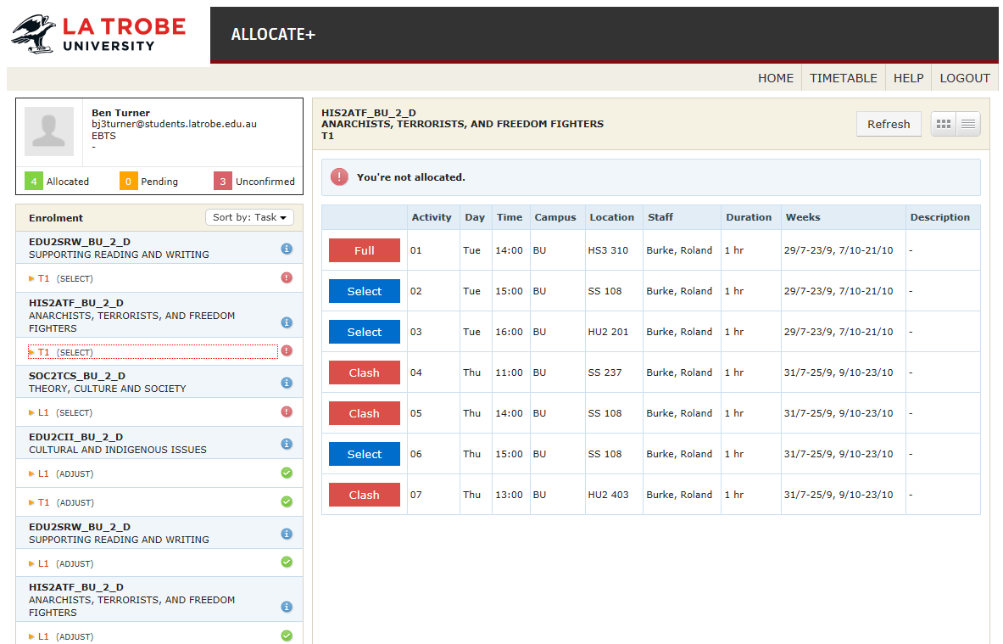
It is suggested that you view all groups that require action and allocate those with fewest activity options first. This will help you to minimise potential clashes.
To allocate yourself to an activity, click on any activity option that is marked as Select, and the class changes to Allocated.
Allocate yourself to an activity in each group, until all groups are marked as allocated, with a green tick.
You can change your allocation by selecting a different activity option that is marked Select, however when you select the alternative activity, then your original allocation will be immediately available for other students to select.
If you withdraw from a subject, your allocations will automatically be removed. If you enrol in any additional subjects via StudentOnLine, you will be able to login to Allocate Plus one hour after your enrolment is finalised to select your class times.

Clashes
While the system works to allocate a clash free timetable, there can be some instances where a clash free timetable is not possible. The system will not finalise your allocations when this is the case. Clashes for some lectures have been pre-approved by subject coordinators. If the clash is caused by an elective you may wish to consider enrolling into an alternative subject. If you have an unavoidable clash in your core subjects, you can contact the Academic Services Student Hub who may force a pre-approved clash. Unapproved clashes will be referred back to the relevant faculty or college.

